Ex No: 5 – ONLINE COURSE RESERVATION SYSTEM
NAME: P.Rohini(192420054)

USE CASE DIAGRAM:
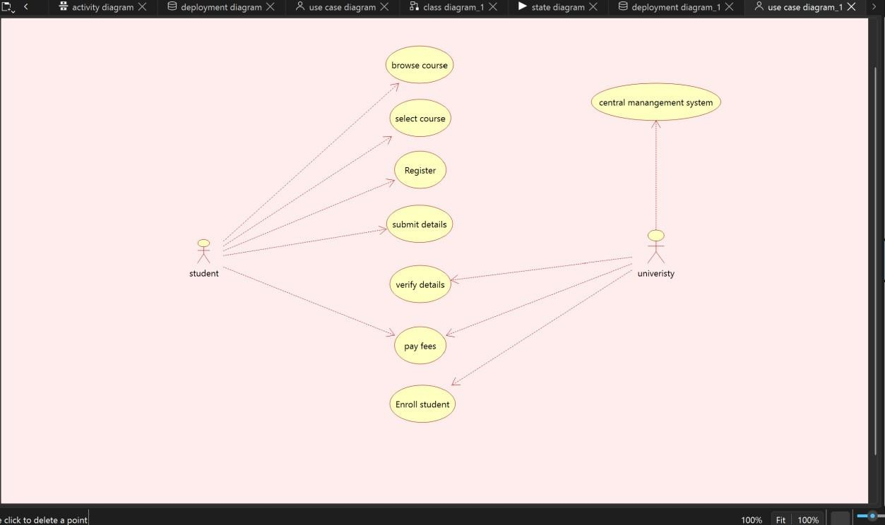

CLASS DIAGRAM:
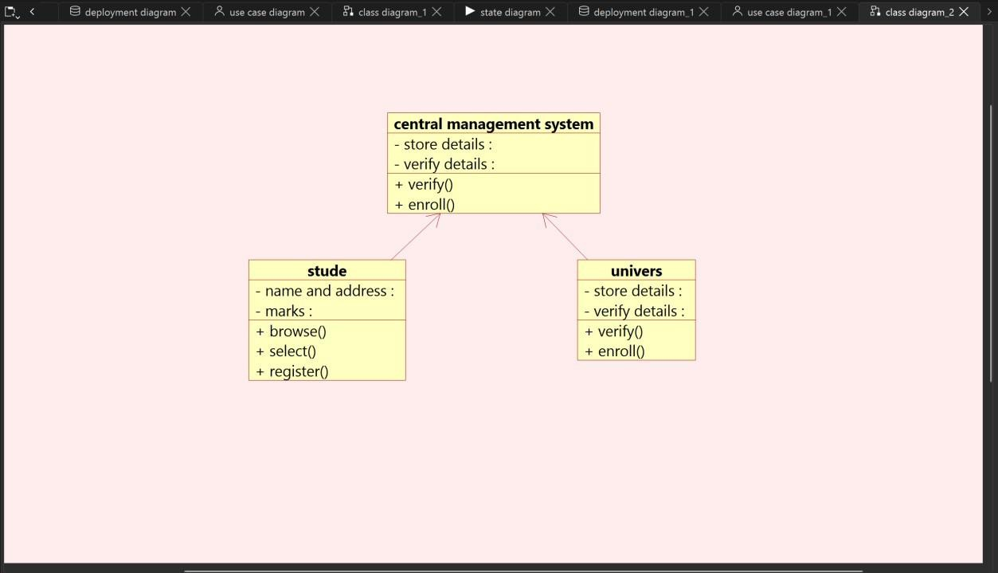

ACTIVITY DIAGRAM:

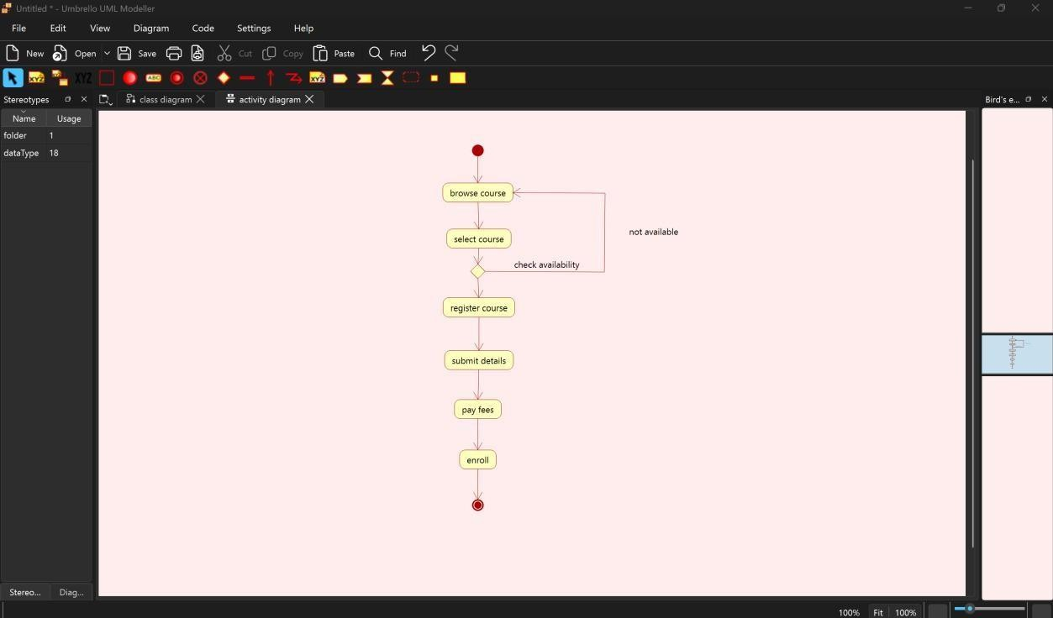

SEQUENCE DIAGRAM:

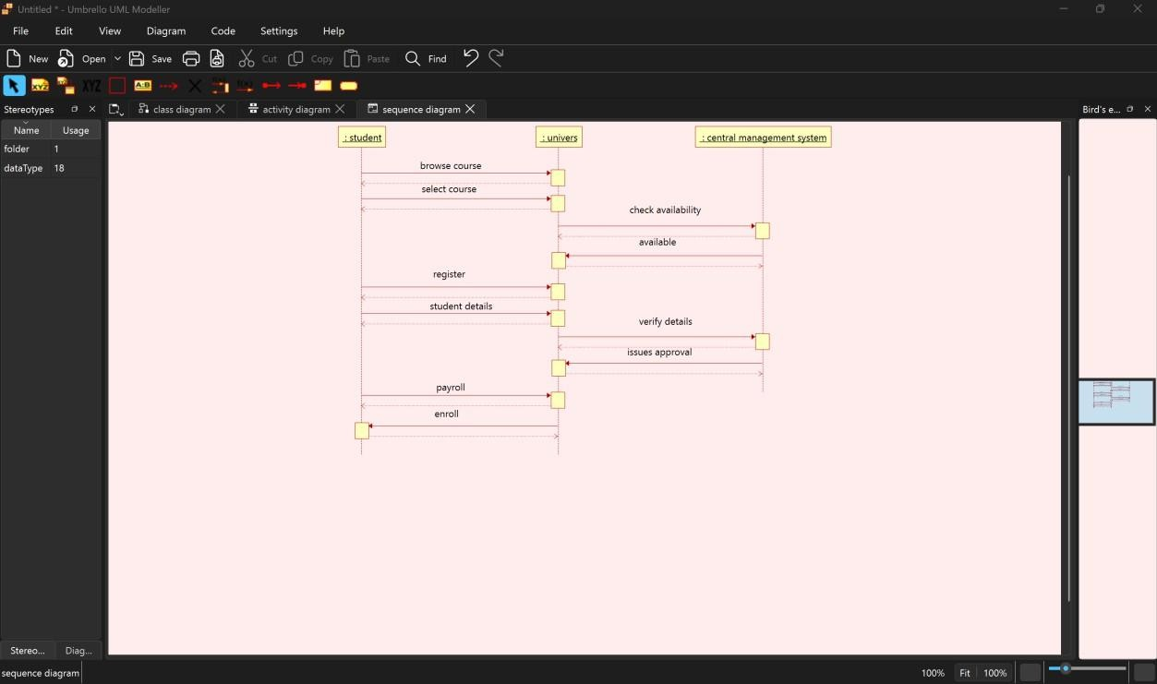

COLLABORATION DIAGRAM:

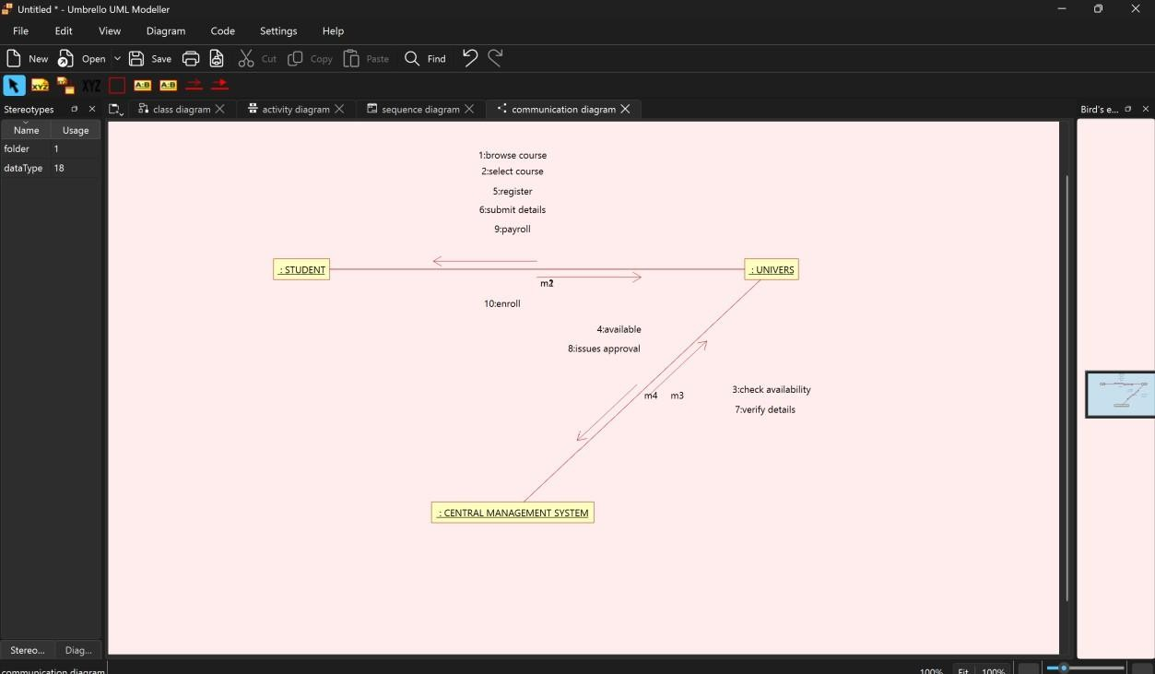

STATE CHART DIAGRAM:

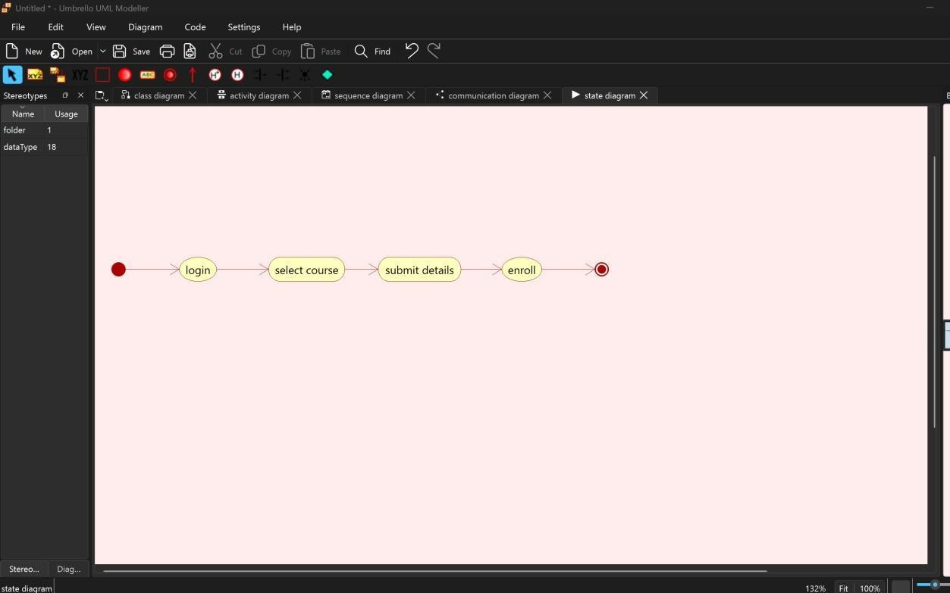

COMPONENT DIAGRAM:

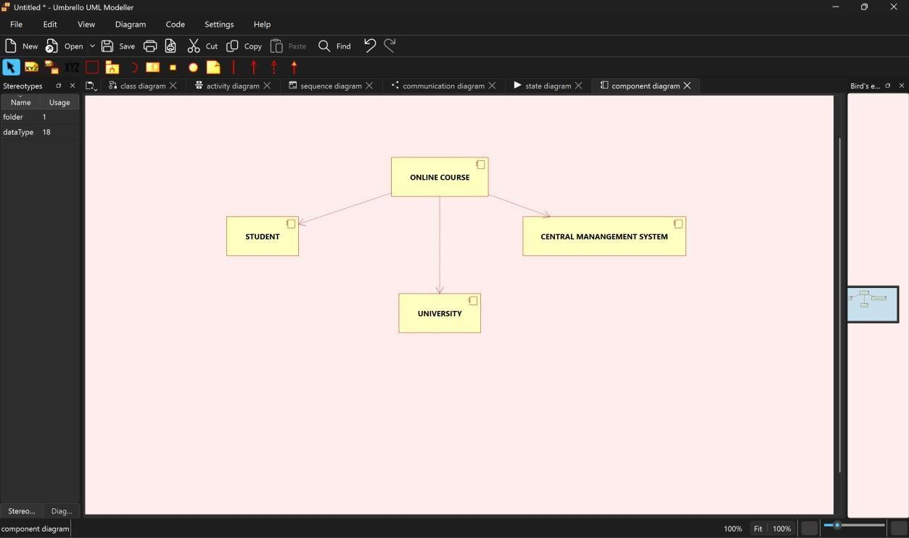

DEPLOYMENT DIAGRAM:

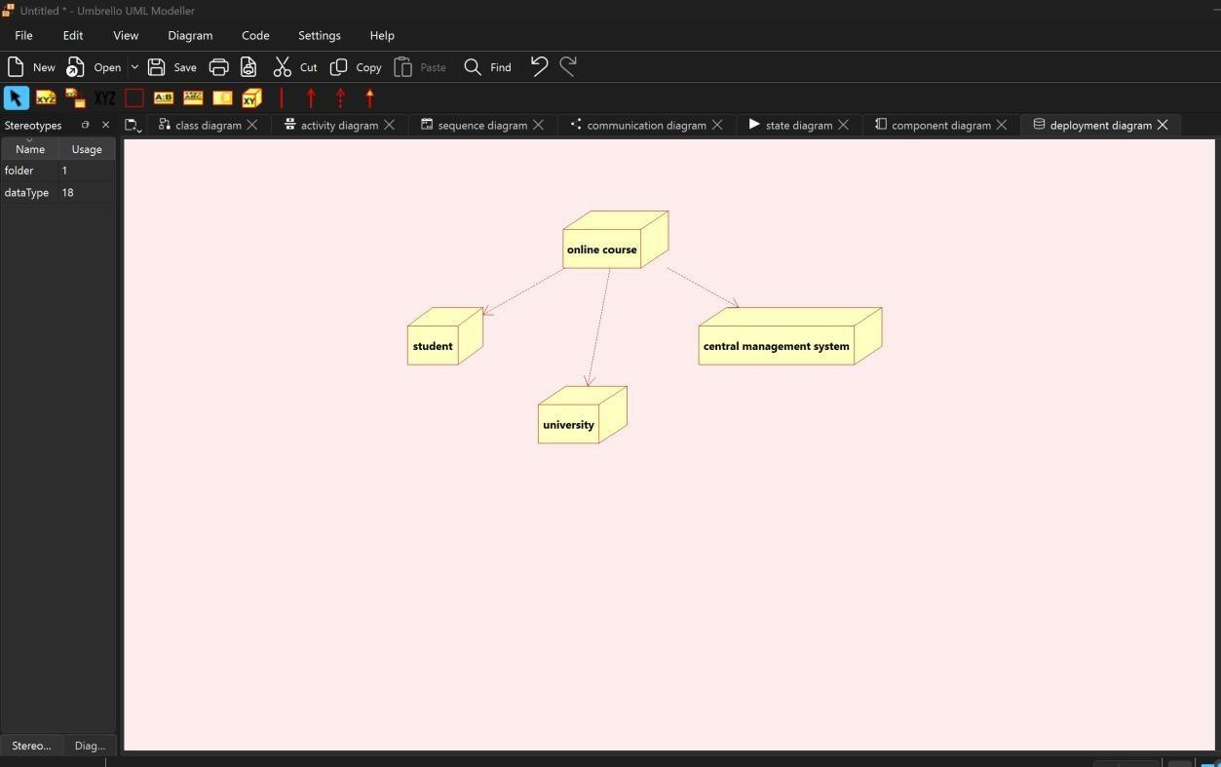

PACKAGE DIAGRAM

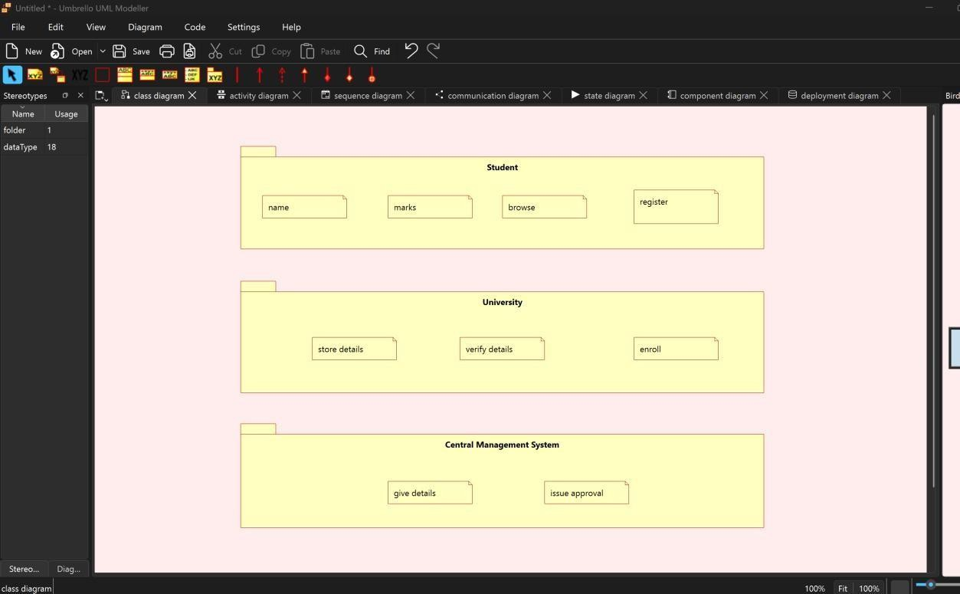

WEBPAGE FOR ONLINE COURSE RESERVATION SYSTEM
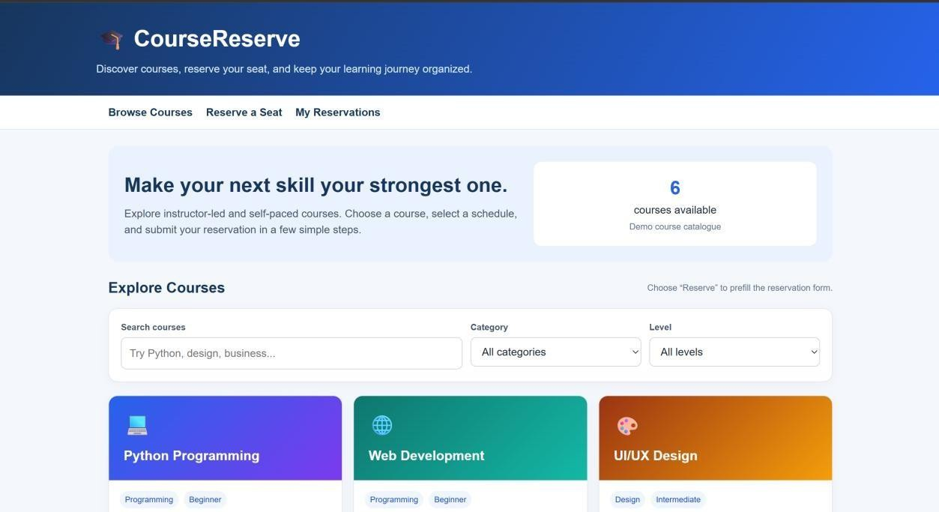



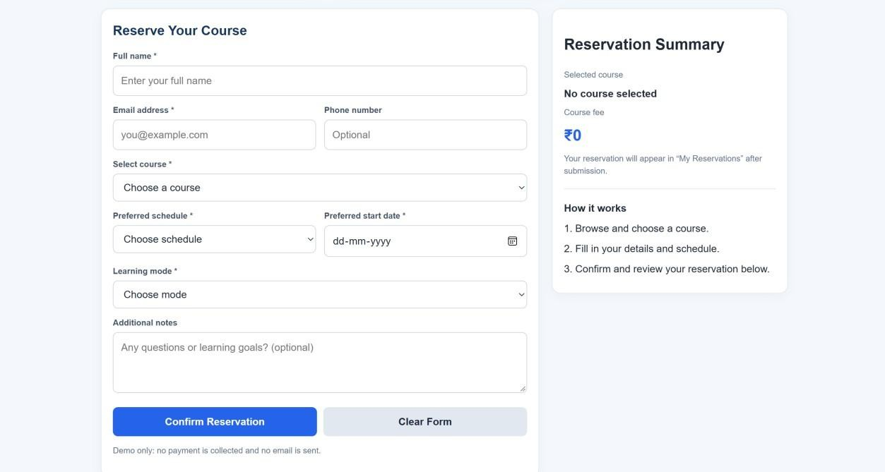

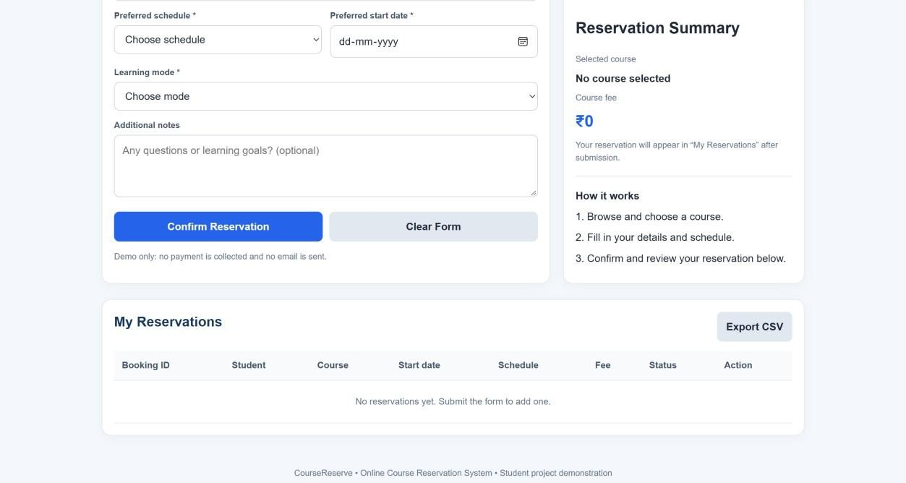

HTML CODE:



